How To Write With Emotion

May 22, 2024

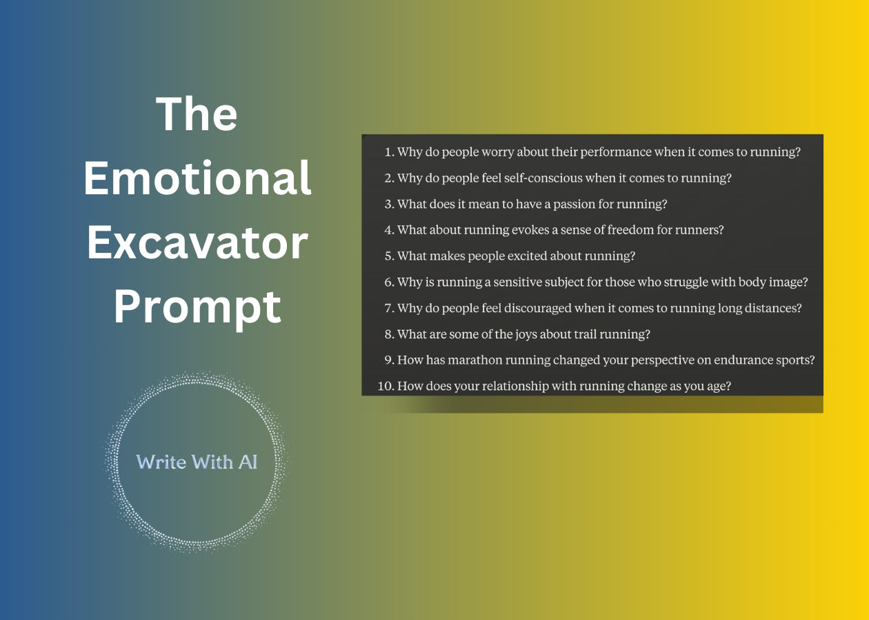

Hey there, Digital Writers!
Think about the last time you read a tip-laden article or step-by-step guide.
Did it stick with you? Did you feel motivated to put the advice into action? If not, the reason is simple.
Information alone doesn't move you. Emotion does.
- You act when you feel understood
- You make decisions based on feelings, not just facts
- You connect with stories and experiences you relate to
Which is why the key to making your advice memorable is to wrap it in an emotional narrative.
But how?
Easy.
Ask Emotional Questions
All writing begins with a question.
So, start with a question that elicits an emotional response.
For example:
- What makes people anxious about writing online?
- Why do readers hesitate when it comes to subscribing to a newsletter?
- How does your relationship with your reader change when you send your newsletter more often?
Unpack the emotion in your answer.
Lean Into Universal Emotions
Everyone can relate to:
- Joy
- Fear
- Regret
- Anxiety
- Surprise
- …
These emotions are timeless regardless of background, culture, or life experience.

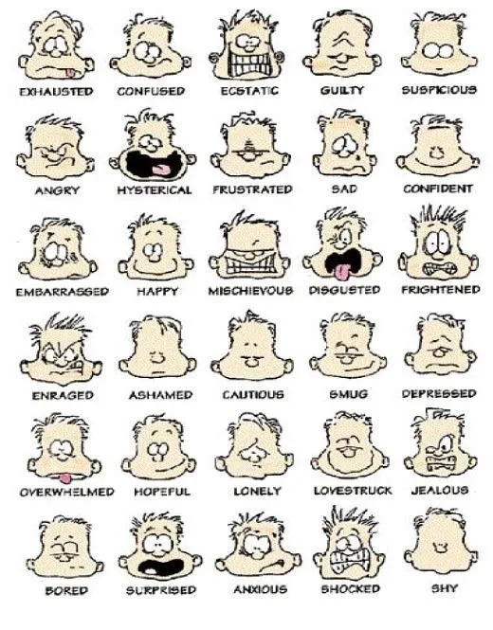

When you blend practical tips with emotional resonance, the reader walks away thinking, "Wow, they totally get what I'm going through. I feel motivated to try this!"
Instead of just collecting more advice, they're inspired to put it into practice. And suddenly, your content isn't just informative—it's transformative. And that's the ultimate goal, isn't it? To help readers make meaningful changes, not just absorb facts.
Now, let's use AI to help.
Explore Your Readers' Feelings With The Emotional Excavator Prompt
The Emotional Excavator helps you probe:
- The problems that keep readers up at night
- The desires that pull at their heartstrings
- The meanings they attach to your topic
Just feed it your topic and it will generate a list of questions you can answer in your next post.
Here's the prompt:
Please generate 10 questions for me using the below templates for my topic.

Topic = {Your Topic}

• Why do people {problem} about {desire}?
• Why do people {problem} when it comes {topic}?
• What does it mean to have {desire} with {topic}?
• What about {topic} evokes {emotion} about {topic}?
• What makes people {specific emotion} about {topic}?
• Why is {topic} a sensitive subject for {audience type}?
• Why do people {emotional problem} when it comes {topic}?
• What are some of the {specific emotion} about {sub-topic}?
• How has {sub-topic} changed your perspective on {related topic}?
• How does your relationship with {topic} change {based on criteria}?

I only want the questions.
How To Use The Emotional Excavator
Replace {Your Topic} with the theme of your article or content.
Example: "Running"
Run the prompt and review the questions it generates.
You'll get 10 questions to choose from.

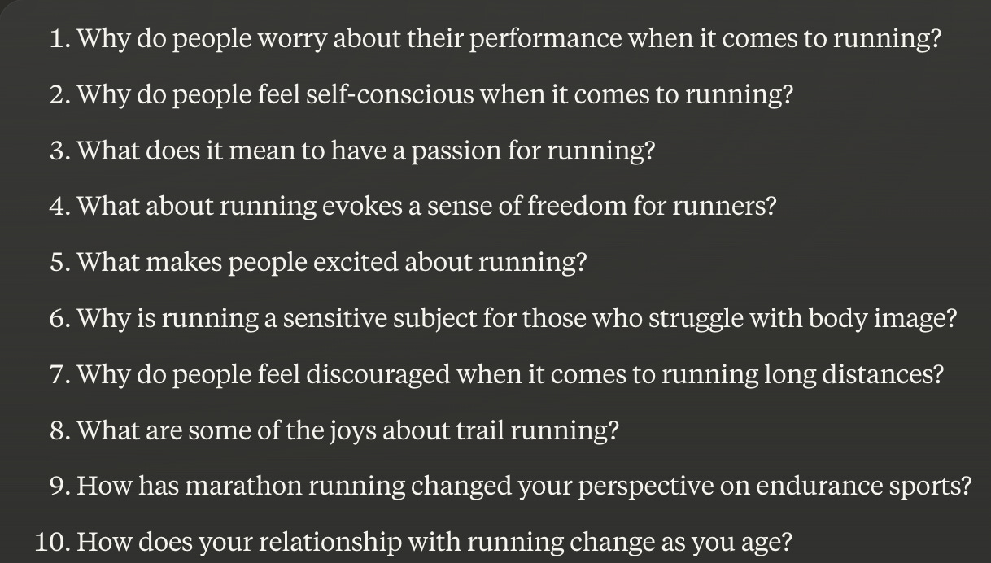

Pick 1 question that raises an "aha!" for you. If it stokes your curiosity, it will be easier to write about it and it’s also more likely to resonate with your readers.
Let's say "Why do people feel self-conscious when it comes to running?" catches your eye. Grab a piece of paper and write down your answer in a bulleted list. Or you can ask AI to generate a list of possible answers for you.
For example:
Please write 5 bullets in response to question {Number}.

Use 10-12 words per bullet.

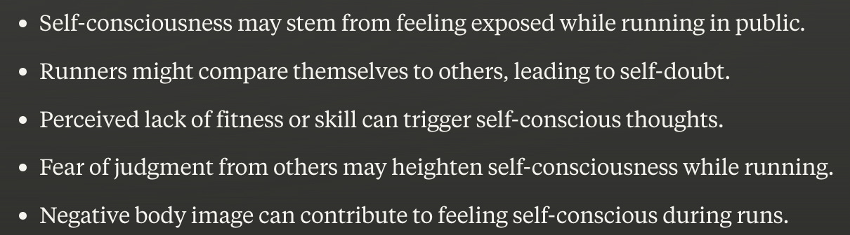

Bang. Now, you’re off to the races.

